RESULTS

# OUTPUT:

SLOW DIVISION:

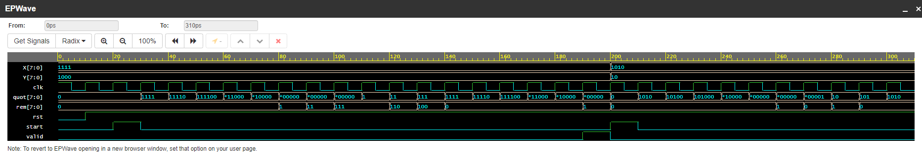

FAST DIVISION:

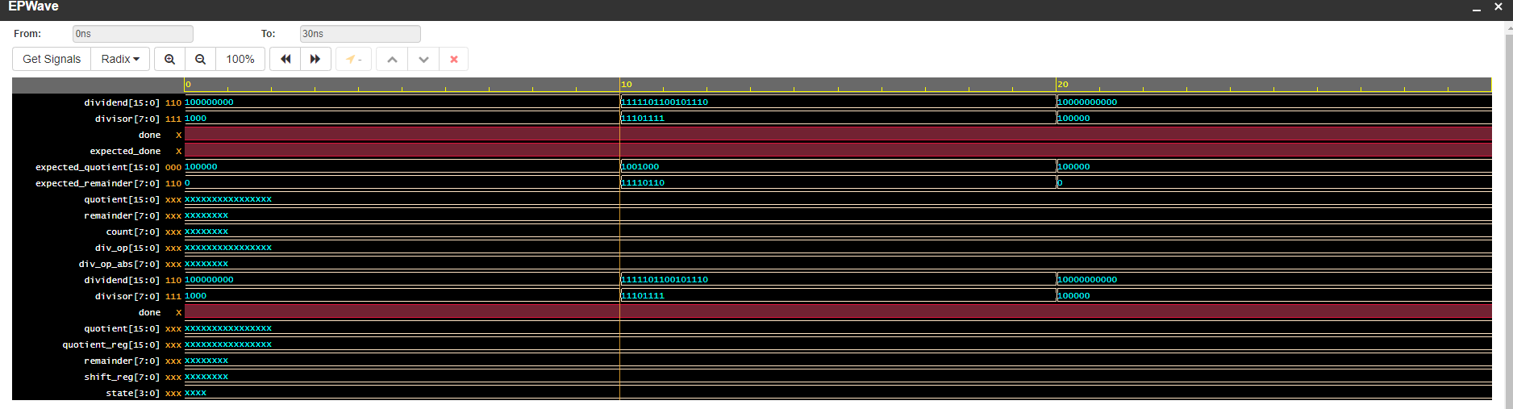

# OBSERVATION:

From the output of the slow division, we can find the waveform and the process of division in which one-bit changes per iteration.

From the output of the fast division algorithm, we can find the quotient and remainder in one step and takes less time compared to slow division algorithm.

# CONCLUSION:

The above outputs are the examples that result in the implementation of slow and fast division algorithm in the computer architecture. We now know that the implementations can be integrated with AIML and can increase the advantages in the sector of HPC (high performance computing) and automatic driving and many more, with these improvements in the application algorithm we can drive towards a better world.